From: Alex Golding, Randy Schur

To: Roger Cortesi, John-Michael Kerwin

**Subject: Latch Design for an Airplane Galley Service Cart**

This document describes the design for an airplane cart latch to be used on commercial jets of varying sizes. These include Boeing 727, 737, 747, 767, DC-10, and A230 models, along with comparable aircraft from other manufacturers. Calculations for static and dynamic loading are included with a safety factor of 1.5[1], based on the eCFR. Equations for the analysis in this memo were taken from Juvinall[2].

## Background

Commercial aircraft are frequently loaded with galley service carts containing refreshments for airline customers. These carts come in various sizes[3] depending on contents and aircraft size. The proposed latch design is for the largest such cart found in normal operation, with a weight of 230 lbs. and dimensions of . The design can be scaled down appropriately using the calculations contained below if the latch will be retaining a smaller load.



Figure Latches in locked and unlocked position[4]

## Functional Requirements

The functional requirements come from the eCFR, with section numbers given as appropriate. Any aircraft design details are taken from typical aircraft in current operation, with data sources cited. Failure of the latch could cause potentially serious injury during normal aircraft operation, which could be disastrous. For this reason, the component is design with a high reliability and an infinite fatigue life.

For our analysis, we will look at the worst-case loading. If this loading can be survived by the latch, then the lighter loaded cases will also survive. As such, we will consider the B-747 Liquor Cart’s weight of 230 lbs, and a static-case g loading of 18 g, as recommended by eCFR 14.23.561.

## Proposed Design

The proposed latch will be made from machined AISI 1040 as-rolled carbon steel. The material was selected for its availability, material properties, and infinite cycle fatigue limit. Tensile strength is 89.9 ksi, yield strength is 60.2 ksi, Brinell Hardness is 201, Young’s Modulus is 29,000 ksi, Poisson’s ratio is .29[5].

CAD model goes here.

## Static Loading Analysis

Free Body Diagram- Static Loading case

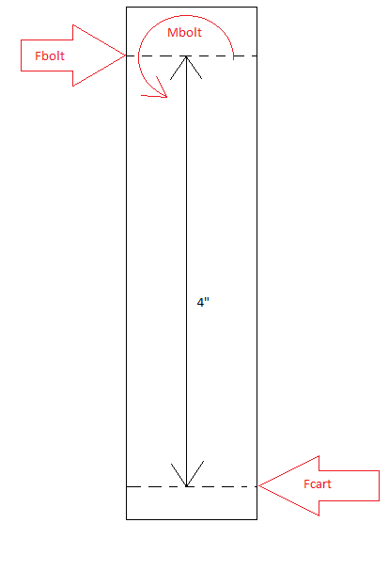

A conservative assumption for the length between the applied force and the center of the bolt was used; based on the pictures, this distance is probably about 2 inches in most cases. Here, we assumed a length of 4 inches, which can help to make up some human error, such as the latch not being fully in the closed position. Another important detail we determined, based on creating drawings in their loaded configuration, is that the material below the highest point on the latch which contacts the cart will help little in terms of resistance to the load. This is because, as the latch is deflected, the bottom section of the latch will lift off of the cart. The diagram below displays this phenomena.

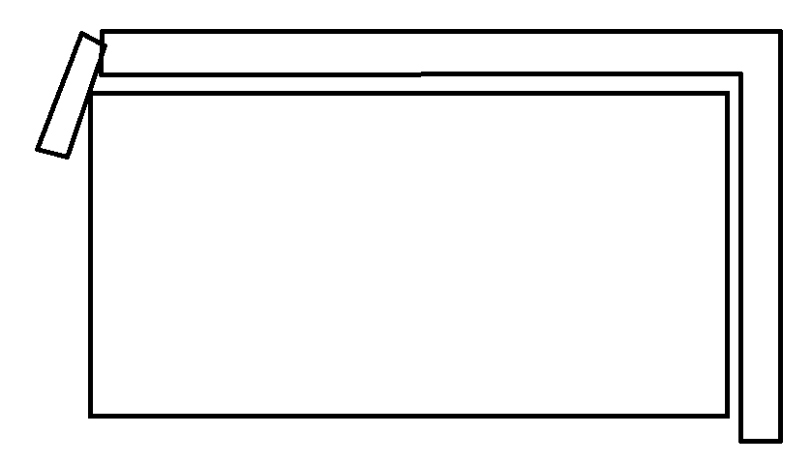

From basic static analysis, it can be seen that the force in the bolt will be equal to the force exerted on the latch from the cart, and the moment in the bolt will be this force multiplied by the distance between the two- in our case, 4”.

With 18 g’s of loading on a 230 lb cart, the maximum expected static load, as referenced by eCFR 14.23.561, would be 4140 lb.

For this analysis, a rectangular cross section was assumed. Using the applied load of 4140 lb and a factor of safety of 1.5 (common in the aviation industry): *where did this equation come from?*

$$b^{2}h^{4}{\left(\frac{σ_{y}}{1.5}\right)}^{2}-h^{2}{F_{cart}}^{2}=36{(F_{cart}×4")}^{2}$$

$$b^{2}h^{4}5.44X{10}^{8}\frac{{lb}^{2}}{{in}^{4}}-h^{2}17139600 {lb}^{2}=36{\left(16560 in-lb\right)}^{2},$$

Where b is the width of the latch and h is its depth, and b*h is the cross sectional area of the latch at and above the region of interest.

The above equation will be used in designing the profile of the surface- it provides requirements on the minimum width and depth of the latch to survive the static loading

## Alternating Stress and Fatigue Analysis

The loads experienced by the cart will not merely be static. In fact, there will be alternating stresses repeated each time the plane experiences turbulence or tilts, which could be hundreds of times per trip. For this reason, the proposed latch is made from steel, which has an infinite fatigue limit. The infinite life strength is calculated from the following equations.

$$S_{n}=S_{n}'C_{L}C_{G}C_{S}C_{T}C_{R}$$

Where

$$S_{n}^{'}= .5*S_{UT}=45 ksi$$

$C_{L}=1$ for a bending load

$C_{G}=0.9$ for a part with the characteristic dimension < 2 inches

$C_{s}=0.65$ for machined steel

$C_{T}=1$ for temperatures near room temperature

$C_{R}= 0.753$ for 99.9% reliability.

The assumptions made above are all realistic. The reliability of 99.9%, in combination with the safety factors and the infinite fatigue analysis below, should assure that these parts do not fail. The above factors give a final value of $S_{n}=19.28 ksi.$

The analysis below uses the Maximum Distortion Energy Theory to predict failure. This theory states that a component will yield if $σ_{e}>S_{y},$ where S­y is the yield stress of the material, and

$$σ_{e}= \frac{\sqrt{2}}{2}{*\left[{\left(σ_{2}-σ_{1}\right)}^{2}+{\left(σ_{3}-σ_{1}\right)}^{2}+{\left(σ_{3}-σ_{2}\right)}^{2}\right]}^{1/2}$$

Or,

$$σ_{e}{=({σ_{x}}^{2}+{σ_{y}}^{2}-σ_{x}σ_{y}+3{τ_{xy}}^{2})}^{1/2}$$

With a safety factor (S.F.),

$$S_{y}=σ_{e}*S.F.$$

In our loading scenario, sx = and sy = and txy =

## Impact Loading Analysis

Due to the nature of an aircraft emergency landing, impact loading is expected to be an issue. Because the ‘static’ load in the emergency landing condition will be 18g, this will be used instead of the weight of the object in determining $δ_{st}$, the static deflection of the structure. Assuming that $δ_{st}$ is a function of only the bending of the latch, it was determined to be:

$$δ_{st}=\frac{0.158976}{bh^{3}}$$

The energy stored in the structure, $U$ was found to be:

$$U= .0007 bh$$

Using a gap of .5” between the cart and the latch, a load factor was found based on a velocity of 83.4 inches/second of relative velocity between the cart and the latch:

$$L.F. =(1+\sqrt{(1+}1.35817bh^{3})$$

This means we can expect an effective load of:

$$F_{e}=4140 lb*L.F.$$

And a deflection of:

$$δ=\frac{0.158976}{bh^{3}} lb*L.F.$$

By solving the energy stored in the structure, $U= .0007 bh$ and the energy added to the structure by the effective load and the deflection, $U= \frac{1}{2}F_{e}δ$, the following equation was found:

$$2.127X{10}^{-5}b^{2}h^{4}-0.0092bh^{2}-1.35817bh^{3}= 0$$

So long as this holds true, the latch will be able to dissipate the energy from the expected impact described above.

## Fastener and Mechanism Design

## Conclusions

# Appendix

## Electronic Code of Federal Regulations Excerpts

14.121.576   Retention of items of mass in passenger and crew compartments.

The certificate holder must provide and use means to prevent each item of galley equipment and each serving cart, when not in use, and each item of crew baggage, which is carried in a passenger or crew compartment from becoming a hazard by shifting under the appropriate load factors corresponding to the emergency landing conditions under which the airplane was type certificated.

[Doc. No. 16383, 43 FR 22648, May 25, 1978]

14.23.561:

(3) The items of mass within the cabin, that could injure an occupant, experience the static inertia loads corresponding to the following ultimate load factors—

(i) Upward, 3.0g;

(ii) Forward, 18.0g; and

(iii) Sideward, 4.5g.

1. eCFR section and paragraph number for the safety factor.
2. Cite Juvinall.
3. Cite the job description thing.
4. Image taken from Design Memo 1 handout
5. All material properties are from [www.matweb.com](http://www.matweb.com), for AISI 1040 steel (as-rolled).